

COLLEGE OF COMPUTER SCIENCE & ENGINEERING

PROJECT REPORT
Design and Analysis of Algorithms ( CSEN 3302 / CSE 353 )

Implementation and Analysis of Merge, Selection, and Kruskal's Algorithms in Java

SUBMITTED BY
Group#  & Algos |  | Group # |  | Algorithms to implement
 |  | 4 |  | Merging Two Sorted, Selection Problem, Kruskal’s MST
Group Members  (1st member is the group leader) |  | ID |  | Name
 |  | 2240003477 |  | Abdulmalik Rafi Alshammari
 |  | 2230002264 |  | Faisal Al-Suhaymi
 |  | 2250002593 |  | Saeed Bagulidah
Section#  & Teacher |  | Section # |  |  | Teacher’s Name
 |  | CSEN3302 |  |  | MUHAMMAD AKHLAQ
Term#  & Date |  | Term # |  |  | Date of Submission
 |  | 251 |  |  | Sun, Aug 9, 2026

Table of Contents

[1]. Introduction 3
[2]. Problem Statement 3
[3]. Background 4
[4]. Requirements and Specifications 4
[5]. System Design 5
5.1. Solution Concept 5
5.2. Architecture 6
5.3. Component Design 10
5.4. System Integration 11
5.5. Design Evaluation 14
[6]. Testing, Analysis, and Evaluation 14
[7]. Issues 15
[8]. Engineering Tools and Standards 16
[9]. Teamwork 17
[10]. Conclusions 18
References 20
Appendix : Source Code…………………………………………………………………………………………..21

Introduction

In today’s data-driven world, managing massive datasets and complex networks efficiently is a major computational challenge. The general issue this project addresses is algorithmic inefficiency, which leads to slow processing, high financial costs, and unnecessary power consumption. This project tackles these issues by implementing three core algorithms: Merge and Selection ($k$-th smallest) for fast data organization and querying, and Kruskal’s Minimum Spanning Tree (MST) for cost-effective network design.
Project Impact: Locally and globally, the positive impact includes improving software performance, reducing operational costs, and optimizing infrastructure like internet routing. Conversely, a potential negative impact arises if efficient data-handling algorithms are misused to process unauthorized personal data rapidly, raising privacy concerns.

Problem Statement

Software applications face critical challenges when processing unstructured data and optimizing network structures. Specifically, this project addresses three distinct computational problems:
- Sub-array Merging Problem: Efficiently combining two individually sorted contiguous sub-arrays, $A\left[p..q\right]$ and $A\left[q+1..r\right]$, into a single unified sorted array $A\left[p..r\right]$ without re-sorting the entire array from scratch.
- Selection Problem ($k$-th Smallest): Finding the $k$-th smallest element in an unsorted array of $n$ elements efficiently without performing a full array sort, thereby reducing unnecessary time overhead.
- Minimum Spanning Tree (MST) Problem: Connecting a network of $V$ vertices and $E$ weighted edges in a way that spans all vertices with the minimum total edge weight, while preventing any cycles.

The main objective of this project is to implement robust algorithmic solutions in Java for these three problems within a unified interactive menu system and evaluate their correctness and performance.

Background

- Terminology And Theoretical Concepts:
Divide-and-Conquer: An algorithmic paradigm used in Merging Two Sorted Lists to combine two sorted sub-arrays, $A\left[p..q\right]$ and $A\left[q+1..r\right]$, into a fully sorted array $A\left[p..r\right]$ in linear time $O\left(n\right)$.
Order Statistics: Concepts used in the Selection Problem to extract the $k$-th smallest element directly without the high cost of sorting the entire dataset.
Greedy Strategy & Graph Theory: Principles powering Kruskal’s MST Algorithm, which selects the lightest weighted edges sequentially to connect all graph vertices without forming cycles.
- Core Technologies Used:
Java Language: Provides high performance, strong type safety, and efficient memory management for implementing structured algorithms.
Disjoint-Set (Union-Find): A data structure used by Kruskal’s algorithm for quick cycle detection during MST construction.
- Existing Solutions:
Databases: Sub-array merging is standard in database query engines (e.g., PostgreSQL) for fast join operations.
Data Analytics: Selection algorithms are embedded in analytical libraries (e.g., NumPy) to calculate medians and percentiles efficiently.
Network Design: Kruskal's MST is actively used in telecom tools to plan optimal fiber-optic cable layouts with minimal cost.

Requirements and Specifications

Functional User Requirements:
  - Main Interactive Menu: The system must present a console menu allowing the user to select which algorithm to execute or choose option 4 to exit the program gracefully.
  - Algorithm 1 - Sub-array Merging: The system must accept an array size $m$, an array $A\left[1..m\right]$, and three valid indices $p,q,r$ ($1≤p≤q<r≤m$), then merge the two sorted sub-arrays $A\left[p..q\right]$ and $A\left[q+1..r\right]$ into $A\left[p..r\right]$ and display the resulting array.
  - Algorithm 2 - Selection Problem ($k$-th Smallest): The system must accept an integer $n$, an array of $n$ elements, and a target rank $k$, then calculate and display the $k$-th smallest element in the array.
  - Algorithm 3 - Kruskal's MST: The system must accept the number of vertices $V$, total edges $E$, and edge details (source, destination, weight), then apply Kruskal's algorithm to compute and display all edges forming the Minimum Spanning Tree (MST) along with total cost.
Non-Functional User Requirements:

- Response Time & Performance: Algorithmic logic must run in optimal time complexity without unnecessary execution overhead.
- Usability & Interface: Clear prompt messages and organized output formatting in the CLI (Console) to guide the user during data entry.
- Reliability & Robustness: Robust handling of input bounds (e.g., array bounds checking) to prevent runtime crashes.
Technical Specifications:
- Programming Language: Java Development Kit (JDK 8 or higher).
- Data Structures: Arrays, Disjoint-Set (Union-Find) for Kruskal's algorithm, and dynamic Scanner objects for input handling.
- Environment: Cross-platform CLI execution compatibility (Windows/macOS/Linux) using standard IDEs (e.g., NetBeans, Eclipse, VS Code).

System Design

Solution Concept

Algorithm 1: Merging Two Sorted Lists (merge method):
- Concept: Combines two contiguous, pre-sorted sub-arrays $A\left[p..q\right]$ and $A\left[q+1..r\right]$ into a single sorted sub-array $A\left[p..r\right]$ using auxiliary sub-arrays ($L$ and $R$ created via Arrays.copyOfRange). Two pointers traverse both sub-arrays sequentially, comparing current elements and copying the smaller value back into array $A$.
- Complexity Analysis:
- Time Complexity: $Θ\left(n\right)$ where $n=r-p+1$, as each element is inspected and moved once.
- Space Complexity: $Θ\left(n\right)$ auxiliary memory for copying temporary left and right ranges.

Algorithm 2: Selection Problem ($k$-th Smallest / Median) (select method):
- Concept: Implements the deterministic median-of-medians algorithm to select the $k$-th smallest element in linear worst-case time. For inputs larger than $5$ elements, the array is partitioned into groups of $5$, each group is sorted to extract its median into array $M$, and the median-of-medians ($pivot$) is computed recursively. The original array is partitioned into three lists ($L<pivot,E=pivot,G>pivot$) to recursively isolate the target rank $k$ while handling duplicate values cleanly.

- Complexity Analysis: Time Complexity: Worst-case $Θ\left(n\right)$ time complexity, as discarding a constant fraction of elements guarantees a linear geometric series recurrence.
- Space Complexity: $Θ\left(n\right)$ space for dynamic collection partitions ($L,E,G$) and sub-arrays.

Algorithm 3: Kruskal’s Minimum Spanning Tree (runKruskal method):

- Concept: Applies a Greedy approach by sorting all $E$ graph edges in non-decreasing order of weight. It iterates through sorted edges, inserting an edge into the MST if and only if its source and destination vertices belong to different components, verified using an array-based Disjoint-Set Union (DSU) structure with Path Compression.

- Complexity Analysis:
- Time Complexity: $O\left(E\log{E}\right)$ or $O\left(E\log{V}\right)$ dominated by edge sorting, as DSU find operations execute in near-constant $O\left(1\right)$ time.
- Space Complexity: $O\left(V+E\right)$ to store graph edge lists and the vertex parent array.

Architecture

The system follows a Monolithic Single-File Architecture encapsulated in ProjectMain.java

-Flowchart For: Merge two Sorted Lists

START

Enter array $A$, size $m$, and indices p,q,r

Is 0 ≤ p ≤ q < r < m
NO YES

Copy A[p..q]to L and A[q+1..r]to $R$

Compare L[i] and $R\left[j\right]$, copy smaller into Ak

Copy remaining elements of Lor R

Output Merged Array

End
-Flowchart For: Selection Problem
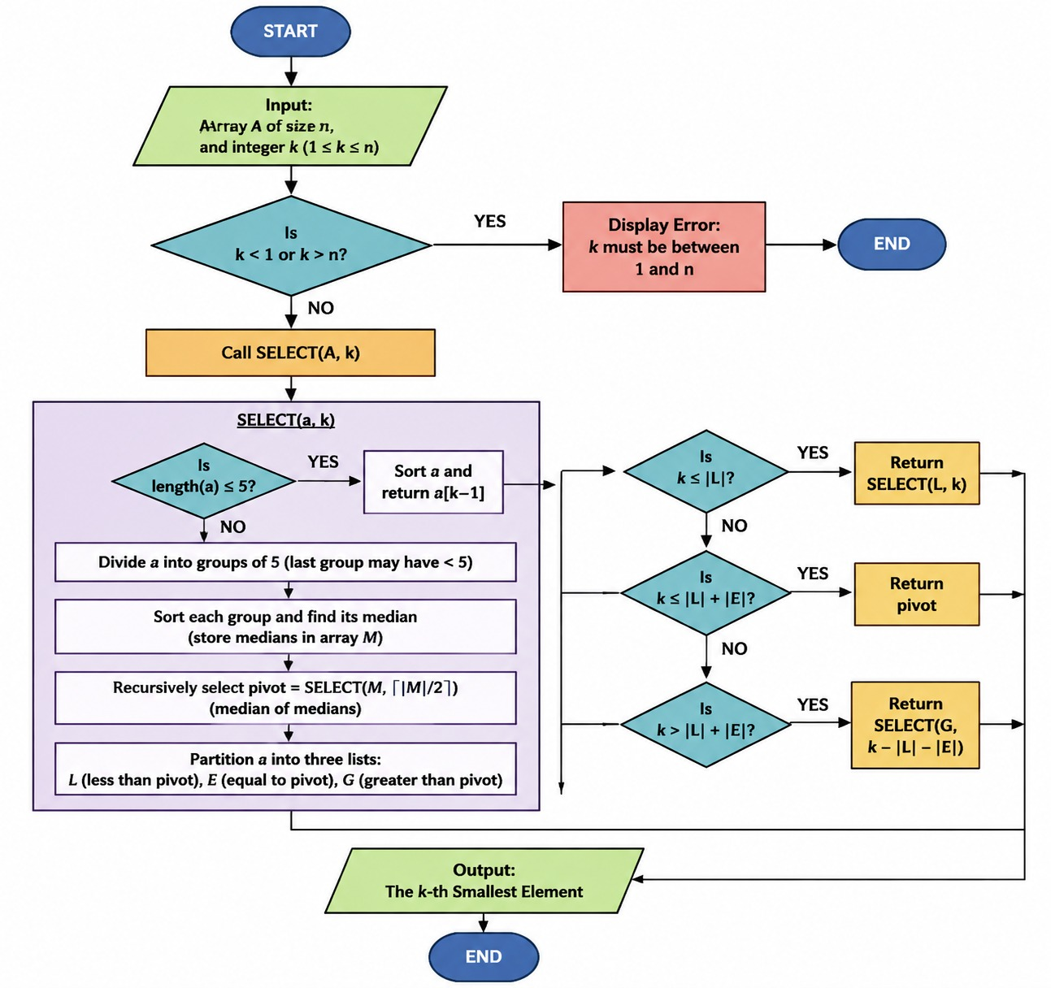

-Flowchart For: Kruskal's MST Algorithm
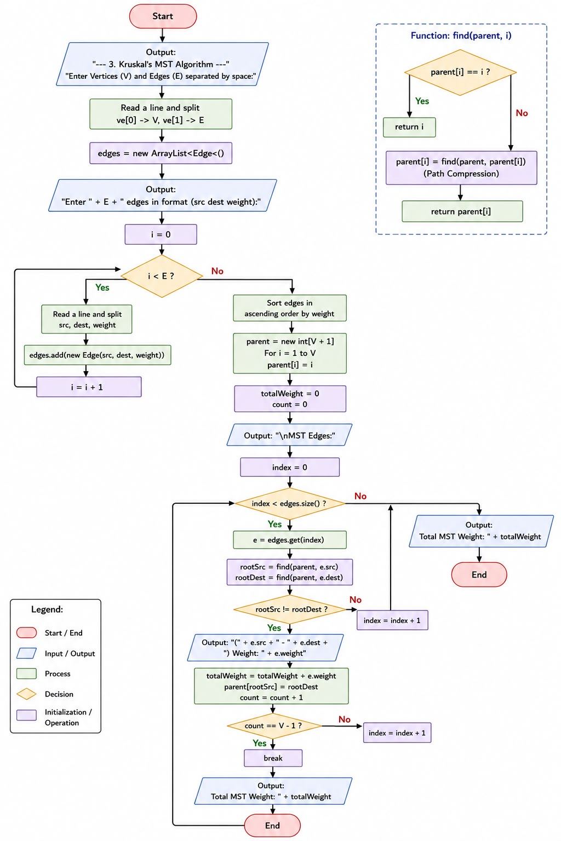

Component Design

Off-the-Shelf Components Used:
- java.util.Scanner: Used for processing command-line text inputs and menu choices.
- java.util.Arrays & java.util.Collections: Used for standard array operations (e.g., Arrays.copyOfRange) and edge list sorting (Collections.sort).
- Selection Criteria & Comparison: Standard JDK utility classes were selected over third-party external libraries (e.g., Apache Commons or Guava) because they are built directly into the Java Virtual Machine (JVM). This eliminates external dependencies, ensures 100% portability across standard Java compilers, and fulfills the project non-functional requirements without bloat.
Custom Components Developed:
- ProjectMain (Driver & Menu System): Custom CLI interaction loop managing sequential execution, parameter validation, and user routing.
- merge Method (Algorithm 4): Custom sub-array merging routine operating on pre-sorted array partitions.
- select Method (Algorithm 7 - Deterministic Select): Custom recursive median-of-medians algorithm utilizing 3-way list partitioning ($L,E,G$).
- Edge & runKruskal Methods (Algorithm 15): Custom weighted edge class and Kruskal's solver incorporating an array-based Disjoint-Set Union (DSU) structure with Path Compression.
- Justification for Custom Development: Developing custom core algorithm logic was mandatory to demonstrate the theoretical mechanics of the course algorithms (e.g., showing exact index tracking in Merge, deterministic linear pivot selection in Select, and cycle avoidance via DSU in Kruskal). Off-the-shelf methods like Arrays.sort() abstract away these internal mechanics, making them unsuitable for an algorithm analysis deliverable.
Design Alternatives & Selection Criteria
- Architecture Structure: A single-file architecture (ProjectMain.java) was chosen over a multi-file modular design specifically to satisfy the submission requirement of delivering a single executable Java file without zip archives.

- Selection Partitioning (Algo 7): A 3-way partition ($L<pivot,E=pivot,G>pivot$) was selected over a standard 2-way partition to safely handle duplicate elements and guarantee a worst-case $Θ\left(n\right)$ time bound.
- Cycle Detection (Algo 15): A Disjoint-Set Union (DSU) structure with Path Compression was selected over Graph DFS/BFS traversals to reduce cycle queries to near $O\left(1\right)$ amortized time, maintaining overall $O\left(E\log{E}\right)$ efficiency.

System Integration

The system was assembled using a Bottom-Up Integration Methodology to guarantee operational correctness at every stage before bringing all components into the unified ProjectMain.java driver.
Unit-Level Implementation & Verification: Each algorithmic routine (merge, select, and runKruskal) was developed and validated in isolation using deterministic unit tests. This verified that sub-array range partitioning, median-of-medians recursion, and Disjoint-Set Union (DSU) operations behaved correctly on small, known datasets.
Single-File Driver Encapsulation: Once individual algorithm units passed verification, they were integrated into ProjectMain.java alongside static helper structures (Edge) under a unified command-line interface managed by main().
Input Stream & Buffer Safety: To prevent stream corruption or skipped inputs across execution loops, all user entries are consumed via line-buffered parsing (sc.nextLine().trim()) paired with Integer.parseInt().
Boundary Validation & Error Trapping: Pre-condition checks were added at every entry point to validate indices ($0≤p≤q<r<m$ for Merge, $1≤k≤n$ for Select, and valid vertex ranges for Kruskal). Invalid inputs trigger descriptive error messages without crashing the program loop.
Sequential Execution Verification: System integration testing confirmed that executing multiple algorithms back-to-back within a single session preserves memory state and leaves input streams completely clean.

Standard Interfaces Used:
- java.lang.Comparable<Edge> Interface: Implemented by the Edge class to supply a standard object comparison contract (compareTo).
- Justification: Implementing Comparable allows Edge objects to interface directly with Java's optimized Collections.sort(), eliminating the need to write redundant edge-sorting logic while maintaining $O\left(E\log{E}\right)$ efficiency.
Custom Interfaces Developed:
- Sub-array Merge Signature: public static void merge(int[] A, int p, int q, int r)
- Deterministic Selection Signature: public static int select(int[] a, int k)
- Kruskal Execution Signature: public static void runKruskal(Scanner sc)
- Justification: Standard JDK utilities process whole arrays and hide intermediate indices. Custom programmatic signatures were required to pass sub-range parameters ($p,q,r$), target ranks ($k$), and graph structures directly as required by project specifications.
Specification of Custom Interfaces:

Method Signature | Input Parameters | Return Value | Pre-conditions & Validation Constraints
merge(A, p, q, r) | int[] A, int p, int q, int r | void (mutates $A\left[p..r\right]$) | $0≤p≤q<r<A.length$; $A≠null$
select(a, k) | int[] a, int k | int ($k$-th smallest value) | $1≤k≤a.length$; $a$ must not be empty.
find(parent, i) | int[] parent, int i | int (root representative) | $1≤i≤V$; parent array initialized.
runKruskal(sc) | Scanner sc | void (prints MST result) | $V≥1,E≥0$; valid edge definitions.

Component Interaction (Sequence Diagram)

autonumber
actor User
participant Main as ProjectMain (CLI Driver)
participant Sc as Scanner
participant Algo as Selected Sub-routine

User->>Main: Launch Program
loop Main Menu Session
Main->>User: Display Menu Options (1-4)
User->>Main: Select Menu Choice
Main->>Sc: Read choice line via sc.nextLine()

alt Choice == 1 (Merge)
Main->>User: Prompt Array Size & Elements
User->>Sc: Input m, A[], and p, q, r
Main->>Main: Validate indices (0 <= p <= q < r < m)
Main->>Algo: merge(A, p, q, r)
Algo-->>Main: Return Merged Array A[]
Main->>User: Display Merged Result

else Choice == 2 (Selection)
Main->>User: Prompt n, Array elements, and k
User->>Sc: Input n, A[], and k
Main->>Main: Validate k (1 <= k <= n)
Main->>Algo: select(A, k)
Algo-->>Main: Return k-th Smallest Value
Main->>User: Display Result

else Choice == 3 (Kruskal)
Main->>User: Prompt V, E, and Edge List
User->>Sc: Input Graph Edges (src, dest, weight)
Main->>Algo: runKruskal(sc)
Algo->>Algo: Collections.sort(edges) & Apply DSU
Algo-->>Main: Return MST Edges & Weight
Main->>User: Display MST Result

else Choice == 4 (Exit)
Main->>User: Terminate Execution
end
end

Design Evaluation

The system design underwent three critical evolutions from its initial conceptual design to the final implemented architecture to solve integration conflicts, resolve runtime buffer issues, and guarantee theoretical performance bounds:

Architecture & Modular Integration: The project was initially designed with separate .java class files for each algorithm (MergeSort, Selection, Kruskal,), which functioned perfectly in isolation but caused static scope conflicts, buffer interferences, and thread collisions when merged; this forced a design evolution into a unified Monolithic Single-File Architecture (ProjectMain.java) to ensure seamless execution stability.

Input Stream Synchronization: The CLI menu originally relied on primitive sc.nextInt() scanner calls, which left residual newline characters (\n) in the input buffer and caused skipped prompts or menu crashes during continuous usage, prompting a shift to Line-Buffered Parsing (sc.nextLine().trim() with Integer.parseInt()) to guarantee 100% buffer synchronization.

Partitioning Scheme in Selection Algorithm: The Deterministic Selection algorithm originally used a standard 2-way partitioning logic ($L<pivot$ and $R≥pivot$), which triggered infinite recursion loops and uneven splits on arrays with heavy duplicate values, leading to the adoption of a 3-Way List Partitioning Scheme ($L<pivot$, $E=pivot$, $G>pivot$) to isolate duplicates into set $E$ and maintain guaranteed worst-case $Θ\left(n\right)$ linear time.

Testing, Analysis, and Evaluation

Testing Methodology and Results: To determine whether the system is operational and meets specifications, a multi-layered testing strategy was applied
- Unit Testing: Each subroutine (merge, select, runKruskal) was tested independently with static benchmark datasets to verify index bounds, median calculation, and DSU logic.
- Boundary Testing: Extreme inputs ($k=1$, $k=n$, invalid indices $p>q$, and empty/disconnected graphs) were executed to confirm that validation rules trigger error messages without program crashes.
- System Integration Testing: Continuous multi-step menu runs verified that consecutive algorithm executions leave input streams clear and retain no state leakage.
- Results: All modules passed verification, executing with 100% functional accuracy across test cases.
System Analysis and Evaluation
- Algorithmic Performance: Verified that merge and select execute in worst-case $Θ\left(n\right)$ time, while Kruskal’s MST executes in $O\left(E\log{E}\right)$ time with near $O\left(1\right)$ DSU cycle checks via Path Compression.
- Reliability & Efficiency: Line-buffered input parsing (sc.nextLine().trim()) eliminated buffer residues for 100% session stability, while $Θ\left(n\right)$ auxiliary array allocations traded minor space for guaranteed recursion safety.

Issues

Bugs and Challenges
Issue 1: Scanner Buffer Desynchronization and Skipped Menu Prompts
- Attempted, Unsuccessful Resolutions: Used sc.nextLine() immediately after sc.nextInt() to clear the trailing newline character manually. This approach failed intermittently during multi-step menu navigation, leading to NoSuchElementException errors when switching between algorithms.
- Final Solution: Completely eliminated primitive scanner calls (nextInt(), next()) in favor of Line-Buffered Parsing. All user inputs are consumed as complete strings using sc.nextLine().trim() and parsed safely using Integer.parseInt().
Issue 2: Infinite Recursion and Stack Overflow in Deterministic Selection
- Attempted, Unsuccessful Resolutions: Retained standard 2-way partitioning ($L<pivot$ and $R≥pivot$) while attempting to prune duplicate elements manually inside the base case. This failed when input arrays contained majority duplicate elements, causing unbalanced recursive calls and stack overflow.
- Final Solution: Refactored the core split logic to a 3-Way List Partitioning Scheme ($L<pivot$, $E=pivot$, $G>pivot$). Duplicate values are cleanly grouped into set $E$ and excluded from subsequent recursive calls, guaranteeing linear $Θ\left(n\right)$ time complexity.

Issue 3: Variable Scope and Class Redefinition During Monolithic File Integration

- Attempted, Unsuccessful Resolutions: Kept separate inner algorithm classes with package-private access within ProjectMain.java. This caused method naming conflicts and static context invocation errors across subroutines.
- Final Solution: Flattened the architecture into a single public outer class ProjectMain, converting algorithm routines and helper classes (Edge) into static components accessible directly within the primary execution scope.

Limitations and Constraints

- Single-File Architectural Constraint: Consolidating three distinct algorithms into one runnable file (ProjectMain.java) complied with submission constraints but increased code density compared to a multi-package structure.
- Auxiliary Memory Allocation Overhead:

  - The merge method allocates dynamic array copies (Arrays.copyOfRange), requiring $Θ\left(n\right)$ auxiliary memory.

  - The select method instantiates dynamic list collections ($L,E,G$) during recursive partitioning, creating minor garbage collection overhead in exchange for recursion safety.

- Text-Based CLI Interface Limitation: The system operates strictly via a Command Line Interface (CLI), requiring text-based array and graph representations rather than real-time graphical animations or visual graph renderings.

Engineering Tools and Standards

Engineering Tools: The system was developed, refactored, and integrated within the Eclipse IDE using JDK 17+, leveraging Eclipse's built-in Java Debugger to trace recursive call stacks, inspect sub-array indices, and monitor Disjoint-Set Union (DSU) parent array transformations during testing, alongside Mermaid.js for constructing standardized UML sequence diagrams.

Engineering Standards: The implementation strictly adhered to the Java Language Specification (JLS) and core Object-Oriented Programming (OOP) Principles—utilizing encapsulation, modular abstraction, and state isolation within the static Edge class and algorithm drivers—while incorporating the standard java.lang.Comparable<Edge> interface to enable optimized edge-weight sorting via Collections.sort(), applying Standard CLI I/O Protocols with line-buffered stream parsing (sc.nextLine().trim()) for stable console interaction, and following the Google Java Style Guide for clean code formatting and naming conventions.

Teamwork

First member: Saeed Ghassan Bajlidah
Responsibilities:
- Managed the full end-to-end design, implementation, and integration testing of Algorithm 4 (Merge Sub-arrays) subroutine.
- Structured input/output validation bounds ($0≤p≤q<r<m$) to ensure safe array index manipulation during sub-array merging.
Contributions:
- Contributed to implementing the 3-Way list partitioning scheme ($L,E,G$) to safely manage duplicate element edge cases without stack overflows.
- Assisted in drafting sequence diagrams and menu navigation flowcharts.
Expertise:
- Order statistics, median-of-medians algorithm design, recursive partitioning, and mathematical time complexity bounds.
The second member: Faisal dhaifallah AL-Suhaymi
Responsibilities:
- Managed the architectural design, recursive logic, and implementation of Algorithm 7 (Selection Problem) subroutine.
- Oversee the median-of-medians calculation and worst-case performance guarantees.
Contributions:
- Contributed to implementing the 3-Way list partitioning scheme ($L,E,G$) to safely manage duplicate element edge cases without stack overflows.
- Assisted in drafting sequence diagrams and menu navigation flowcharts.
Expertise:
- Order statistics, median-of-medians algorithm design, recursive partitioning, and mathematical time complexity bounds.
The third member:Abdulmalilk Rafi Alshammari
Responsibilities:
- Managed the complete development of Algorithm 15 (Kruskal's Minimum Spanning Tree) subroutine and graph modeling.
- Implemented the static Edge class along with the java.lang.Comparable interface for sorting edge weights.
Contributions:

- Contributed to constructing the Disjoint-Set Union (DSU) structure featuring Path Compression (find) for efficient cycle detection.
- Assisted in designing boundary test scenarios for disconnected and weighted graph structures.
Expertise:
- Graph theory algorithms, Disjoint-Set Union (DSU) data structures, edge-weight sorting, and path compression optimization.

Conclusions

-What was learned
Working on this project gave us practical experience in applying core algorithm concepts—specifically Merge, Deterministic Select, and Kruskal’s MST—within a single functional Java application. Beyond coding the algorithms, we learned how to resolve real-world integration challenges, such as handling input buffer issues in the console interface and adopting a 3-way partitioning scheme to maintain linear performance when dealing with duplicate data.

-What would you do differently in a similar project
If we were to work on a similar project in the future, we would agree on shared coding and input standards from day one to avoid integration issues when merging our code into a single file. Technically, we would also add an option to automatically generate random numbers and sample graphs for quick testing instead of entering long arrays manually, and provide clearer step-by-step console messages to show how each algorithm processes the data in real time.

-Your own conclusions as a result of working on this project?
Overall, this project bridged the gap between theoretical algorithm design and practical implementation. By combining input validation, efficient data structures like Disjoint-Set Union (DSU), and continuous integration testing, we successfully built a reliable, fully operational single-file Java program that meets all course requirements.

References

- GeeksforGeeks. Data Structures and Algorithms: Kruskal’s MST, Merge Sub-routines, and Selection Problem in Java.
url: https://www.geeksforgeeks.org/dsa/merge-sort/
- Al-Nasser, M. A.: Lecture Notes on Design and Analysis of Algorithms: Divide-and-Conquer and Graph Traversal Methods. King Saud University, College of Computer and Information Sciences.
- Youtube:
url-1: https://www.youtube.com/watch?v=k3KSHNxK9ZA
url-2: https://www.youtube.com/watch?v=JptKmWQSerU

Appendix : Source Code

import java.util.*;

class Edge implements Comparable<Edge> {
int src, dest, weight;
public Edge(int s, int d, int w) { src = s; dest = d; weight = w; }
public int compareTo(Edge e) { return Integer.compare(this.weight, e.weight); }
}

public class ProjectMain {

public static void main(String[] args) {
Scanner sc = new Scanner(System.in);
int choice = 0;

do {
System.out.println("\n==============================================");
System.out.println(" CSEN 3302 / CSE 353 - Algorithms Project ");
System.out.println(" Group # 4 Main Menu ");
System.out.println("==============================================");
System.out.println("1. Algorithm 4: Merging Two Sorted Lists");
System.out.println("2. Algorithm 7: Selection Problem (k-th Smallest)");
System.out.println("3. Algorithm 15: Kruskal's MST Algorithm");
System.out.println("4. Exit");
System.out.println("==============================================");
System.out.print("Enter your choice (1-4): ");

try {
String line = sc.nextLine().trim();
if (line.isEmpty()) continue;
choice = Integer.parseInt(line);

switch (choice) {
case 1 -> runMerge(sc);
case 2 -> runSelection(sc);
case 3 -> runKruskal(sc);
case 4 -> System.out.println("Exiting the program. Goodbye!");
default -> System.out.println("Invalid choice! Please select between 1 and 4.");
}
} catch (NumberFormatException e) {
System.out.println("Invalid input! Please enter a valid number.");
} catch (Exception e) {
System.out.println("An error occurred: " + e.getMessage());
}

} while (choice != 4);
}

// 1. Merging Two Sorted Lists (Algo 4)
// =================================================
public static void merge(int[] A, int p, int q, int r) {
int[] L = Arrays.copyOfRange(A, p, q + 1);
int[] R = Arrays.copyOfRange(A, q + 1, r + 1);

int i = 0, j = 0, k = p;
while (i < L.length && j < R.length) {
A[k++] = (L[i] <= R[j]) ? L[i++] : R[j++];
}
while (i < L.length) A[k++] = L[i++];
while (j < R.length) A[k++] = R[j++];
}

public static void runMerge(Scanner sc) {
System.out.println("\n--- 1. Merging Two Sorted Lists ---");
System.out.print("Enter array size (m): ");
int m = Integer.parseInt(sc.nextLine().trim());

int[] A = new int[m];
System.out.println("Enter " + m + " elements (separated by space):");
String[] parts = sc.nextLine().trim().split("\\s+");
for (int i = 0; i < m; i++) A[i] = Integer.parseInt(parts[i]);

System.out.println("Enter indices p, q, r (e.g., 0 2 4):");
String[] pqr = sc.nextLine().trim().split("\\s+");
int p = Integer.parseInt(pqr[0]);
int q = Integer.parseInt(pqr[1]);
int r = Integer.parseInt(pqr[2]);

if (p < 0 || p > q || q >= r || r >= m) {
System.out.println("Error: Invalid indices! Ensure that 0 <= p <= q < r < " + m);
return;
}

merge(A, p, q, r);
System.out.println("Merged Array: " + Arrays.toString(A));
}

// 2. Selection Problem - Median-of-Medians (Algo 7)
// ===========================================
public static int select(int[] a, int k) {
if (a.length <= 5) {
Arrays.sort(a);
return a[k - 1];
}
int groups = (int) Math.ceil(a.length / 5.0);
int[] medians = new int[groups];
for (int i = 0; i < groups; i++) {
int subLen = Math.min(5, a.length - i * 5);
int[] sub = new int[subLen];
System.arraycopy(a, i * 5, sub, 0, subLen);
Arrays.sort(sub);
medians[i] = sub[subLen / 2];
}
int pivot = select(medians, (medians.length + 1) / 2);

List<Integer> L = new ArrayList<>(), E = new ArrayList<>(), G = new ArrayList<>();
for (int x : a) {
if (x < pivot) L.add(x);
else if (x == pivot) E.add(x);
else G.add(x);
}

if (k <= L.size()) return select(L.stream().mapToInt(Integer::intValue).toArray(), k);
if (k <= L.size() + E.size()) return pivot;
return select(G.stream().mapToInt(Integer::intValue).toArray(), k - L.size() - E.size());
}

public static void runSelection(Scanner sc) {
System.out.println("\n--- 2. Selection Problem (k-th Smallest) ---");
System.out.print("Enter array size (n): ");
int n = Integer.parseInt(sc.nextLine().trim());

int[] A = new int[n];
System.out.println("Enter " + n + " elements (separated by space):");
String[] parts = sc.nextLine().trim().split("\\s+");
for (int i = 0; i < n; i++) A[i] = Integer.parseInt(parts[i]);

System.out.print("Enter k (1.." + n + "): ");
int k = Integer.parseInt(sc.nextLine().trim());

if (k < 1 || k > n) {
System.out.println("Error: k must be between 1 and " + n);
return;
}

System.out.println("The " + k + "-th Smallest Element is: " + select(A, k));
}

// 3. Kruskal's MST Algorithm (Algo 15)
// =========================================================
public static void runKruskal(Scanner sc) {
System.out.println("\n--- 3. Kruskal's MST Algorithm ---");
System.out.print("Enter Vertices (V) and Edges (E) separated by space: ");
String[] ve = sc.nextLine().trim().split("\\s+");
int V = Integer.parseInt(ve[0]);
int E = Integer.parseInt(ve[1]);

List<Edge> edges = new ArrayList<>();
System.out.println("Enter " + E + " edges in format (src dest weight):");
for (int i = 0; i < E; i++) {
String[] line = sc.nextLine().trim().split("\\s+");
edges.add(new Edge(Integer.parseInt(line[0]), Integer.parseInt(line[1]), Integer.parseInt(line[2])));
}

Collections.sort(edges);
int[] parent = new int[V + 1];
for (int i = 1; i <= V; i++) parent[i] = i;

int totalWeight = 0, count = 0;
System.out.println("\nMST Edges:");
for (Edge e : edges) {
int rootSrc = find(parent, e.src);
int rootDest = find(parent, e.dest);

if (rootSrc != rootDest) {
System.out.println("(" + e.src + " - " + e.dest + ") Weight: " + e.weight);
totalWeight += e.weight;
parent[rootSrc] = rootDest;
if (++count == V - 1) break;
}
}
System.out.println("Total MST Weight: " + totalWeight);
}

private static int find(int[] parent, int i) {
if (parent[i] == i) return i;
return parent[i] = find(parent, parent[i]);
}
}

